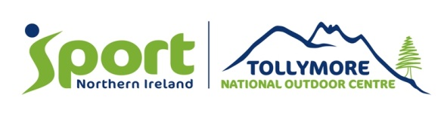
Sample Programme for primary school group
(This sample programme is based on a group arriving mid-morning)
 | Morning | Afternoon | Evening
Day 1 | Settle in, brief and ice breakers | Climbing Wall Skills | Beach walk
Day 2 | Canoesport Skills | Climbing Wall Skills | Hill walk preparation
Day 3 | Hill Walk/Navigation Skills | Hill Walk/Navigation | Low Ropes Course
Day 4 | Mountain Biking Skills | “Leave No Trace”  Camp-craft | Self-Programme
Day 5 | Wet Bouldering | Departure

All skills course will include certification by Tollymore National Outdoor Centre and this will be to National Governing Body (NGB) standard, however there will be the option to obtain NGB certification at an additional cost. For further information on these costs please contact the Centre directly to discuss. Tel: +44 028 4372 2158.

