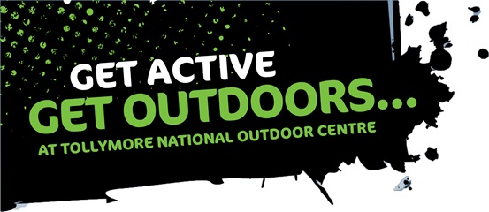
Outdoor Skills Development Residential
Monday, 26th to Friday, 30th October 2015
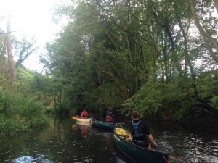
Many young people struggle to arrange the “residential” section of their youth achievement awards and so Tollymore National Outdoor Centre aims to help bridge this gap and provide a fantastic opportunity to take part in an outdoor skills development residential.
This programme may be suitable to be used for the ‘residential’ section of their respective awards such as Duke of Edinburgh Gold Award and An Gaisce (President’s Award), however, prospective students are advised to check with their leaders before booking.
Participating students will:
- develop new skills in a variety of outdoor sports;
- make new friends with people who are also undertaking their gold award;
- develop their personal leadership and teamwork skills;
- learn how to be a responsible outdoor user and gain the Leave No Trace Awareness Certificate; and
- will have an opportunity to look at next steps to leadership in mountaineering, canoeing or mountain biking activities.
Cost: £308 (this includes equipment, in course transport, coaching, food and accommodation)
For more information check out our website at www.tollymore.com where you can book online or alternatively contact us on +44 (028) 4372 2158 or email us at livetheadventure@tollymore.com .

